California High School Academic Booster Meeting - Nov 2020

Date / Time: 7 – 9 PM, PST, November 30th, 2020
Agenda:
1 | Call to Order / Welcome | Anshu
2 | Introduction of new members – Lei Yang and  Joanne Hunt | Anshu
3 | Special Item – Club (esp. Mock Trial and Speech Debate) requests | Anshu
4 | Minutes as of Nov 2020 | Sarah/other
5 | Principal’s Report | Megan
6 | Financial Secretary’s Report as of Sep 2019 | Wunmi
7 | Treasurer’s Report as of Sep 2020  - Checks  - Audit | Susan
8 | President’s Report | Anshu
9 | Committee Reports
 | · Matching Gifts/Future Fund Communications | Sarah/Carol
 | · Communications | Monica
 | . Scholarships | Monica/Wunmi
10 | Other Business
 | Adjourn

Attendees:
- Anshu Jain – President
- Tucker Farrar – Vice Principal
- Susan McGrath – Treasurer
- Sarah Eddings – Economics teachers
- Monica Belani – Communications
- Wunmi Kamson – Financial Secretary
- Carol Moore –
- Joanne Hunt – Director (New)
- Lei Yang – Secretary (New)

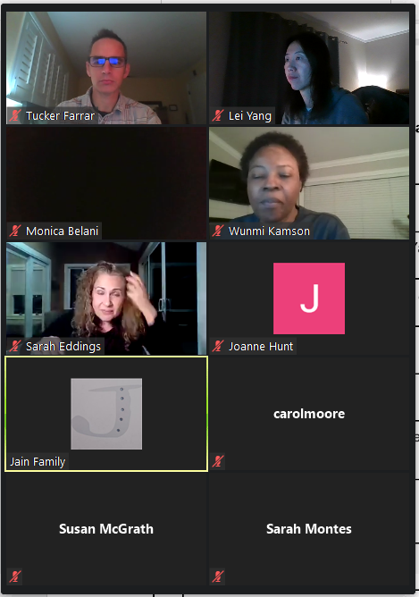

Detail Meeting Agenda:

- Call to Order / Welcome – Anshu
- Introduction of new members – Anshu
Welcome to new members – Lei and Joanne Hu

The committee approved the following roles:
- Lei Yang - Secretary
- Joanne Hu – Directors, will contact Susan offline for role and responsibilities
Other members introduction:
- Monica Belani – Ed Fund, just graduated from high school, 2kids in Cal High

- Special Item – Club (esp. Mock Trial and Speech Debate) requests - Anshu
  - Two Academic teams reached out to request $1000 fund – Mock Trial and Speech Debate
  - Should we do it for 2 teams or all teams - $1000 each team
    - Team can keep it and use for the following year
    - Susan McGrath – not sure to do for the rest of the clubs.
    - Normally the clubs will present and will request
    - In the past, we will give to the club, if within the budget $1000. If more than $1000, need to justify for it.
    - Anshu is Ok with giving only the 2 teams requested it.
    - Sarah Eddings
      - This year is un-predictable, for hybrid.
      - How technology will work
      - If we are not sure we need it, it may make sense to keep it, giving all the unknowns coming
  - Decision:
    - For Mock Trail and Speech and Debate, Anshu will go back to the teams and ask the exact needs and we can decide to approve it or not.
    - The team will let us know and make the decision next time. Susan will write the check.

- Minutes as of Nov 2020 - Sarah/other
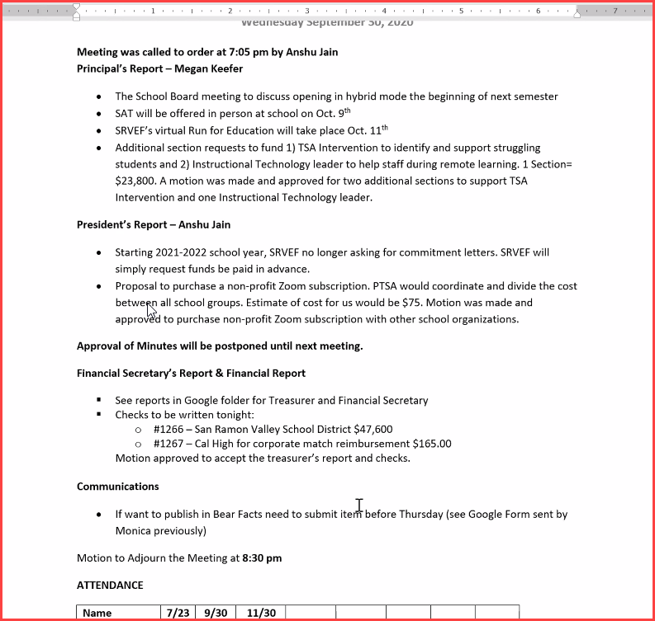
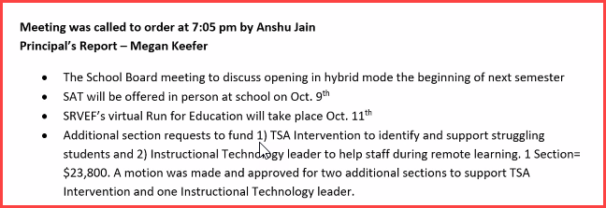

5. Principal’s Report as of Sep 2019 - Tucker
- Creating 2 master calendars for Cal High
- 70% of remote, 30% hybrid
- Some shifting of teachers. Thinking in the next week, will be available for teachers. Next Wed – students asynchronous works, teachers will be getting ready for the spring semesters
- Thrive week – postponed. We are waiting on California Interscholastic Federation (CIF) on sports. Right now, try out for fall sports, wait for CIF’s approval
- Help kids from non-passing to non-passing. Emotionally and academically
- Was VC models considered – yes, initially, teachers working with district, was not the best model. The way flushed out. Many teachers will do VC, because of the class type, special course, one session, teachers inevitable. Teachers will do VC, live. For medical reasons, some students need to be remotely.
- Dec 14th – PTSA meeting, Megan will be addressing the remote\hybrid model coming.

6. Financial Secretary’s Report as of Sep and Oct 2020 – Wunmi Kamson
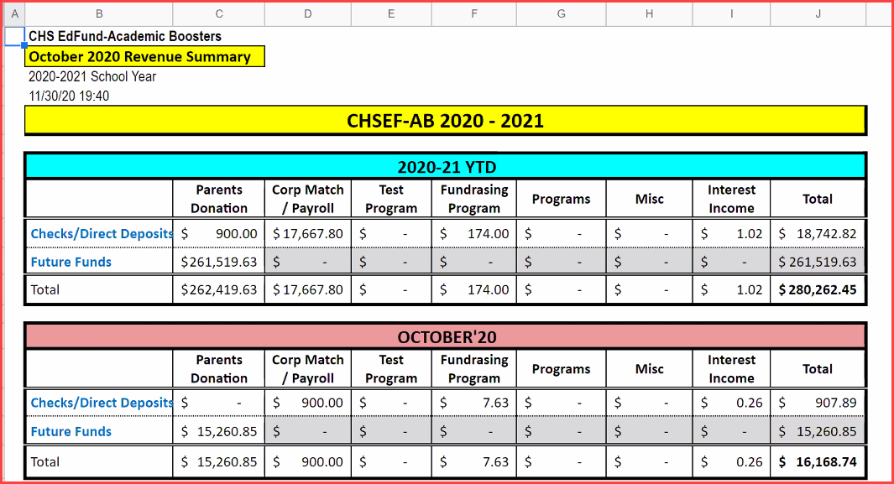
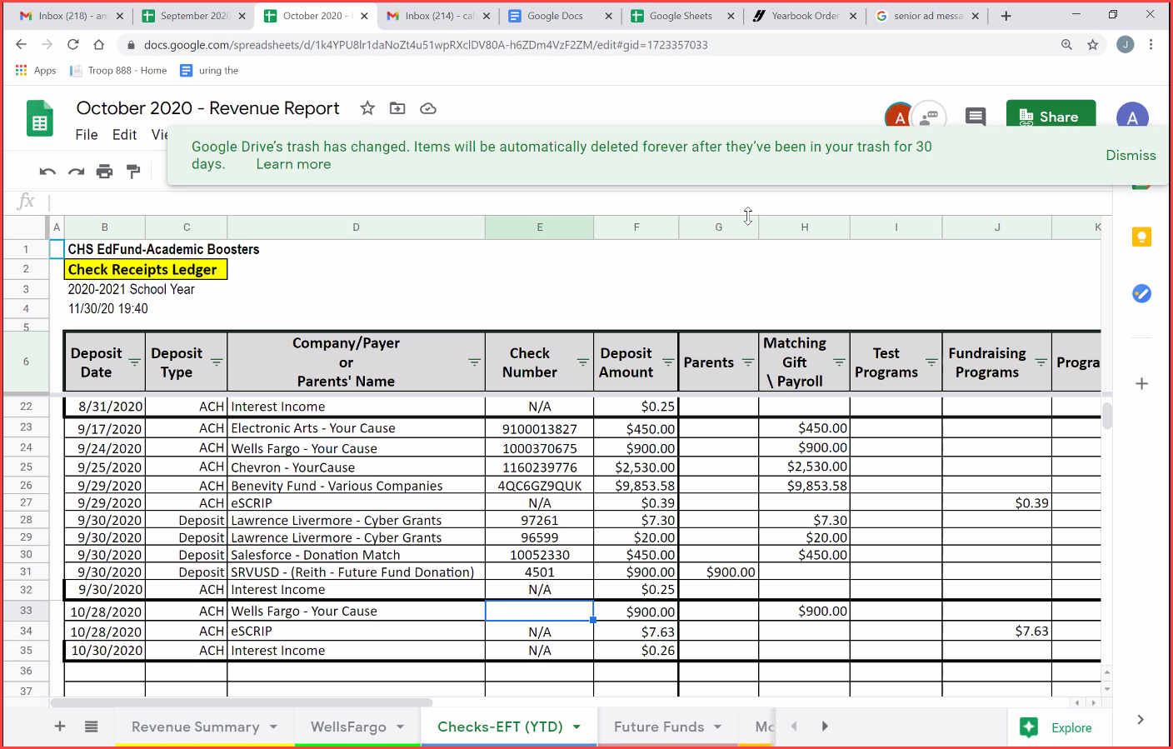

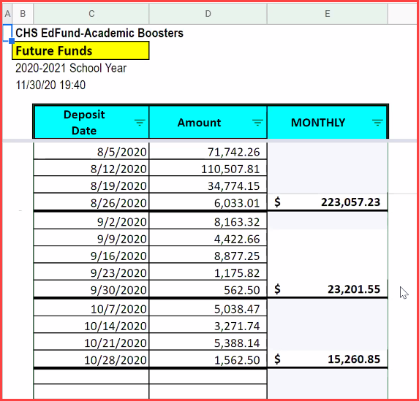
- Neither Wunmi nor Susan has access to future funds; Susan has access to the bank
- John has access to the future funds. There should be reconciliation and transfer the authority to manage the Future Funds.
- ACTION
  - Susan need to have access to future fund
  - Anshu will email Jeff Osborne – Future Fund Guru to Wunmi to the future funds

7. Treasurer’s Report as of Sep 2020 - Susan
- Checks
- Audit
- Newer expenses – Tax prep fees, refunds to other programs
- ACTION:
  - Insurance check – Susan McGrath will send out list of checks to Lei for meeting notes - Done
1. #1268 to Terri Crinnion for $730.00 (Annual Tax Prep Fees)
2. #1269 to Jeanne Won of PTA for $69.81 (Partial PTA Zoom share reimburse)
3. #1270 to SRVPTA for $5.19 (remaining Zoom share reimburse)
4. #1271 to SRVEF for $450.00 (Annual Affiliate Dues)
5. #1272 to CA Dept. of Justice for $75.00 (Annual NFP Registration Fee)
6. #1273 to Traveler’s Insurance for $257.00 (Annual Liability Insurance)

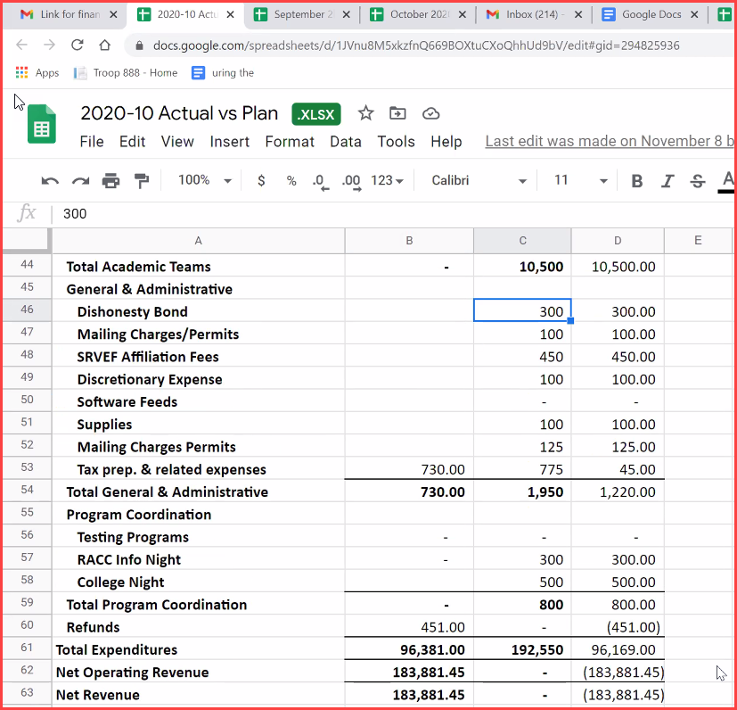
8. President’s Report – Anshu
- After the super SRVF meeting, the report is pretty the same
- This year is uniqut in terms of section funding. We have committed to prior years. Next year we will go to the normal model.
In Feb, we will get similar questions the year before.

9. Committee Reports - Sarah and Carol
- Matching Gifts/Future Fund Communications
  - The same as last year, received checks. More like for other orgs. Will hear back from Tressa.
  - Sarah – donations are slightly down. We are good. We are please considering this is a unique year.
  - Always get ACH – hold on some checks.
  - For marching funds – what is the budget for the marching funds.
- Communications – Monica
  - Running repeat
  - Additional funding to help students. Megan to get back. Can reach out.
  - Thank you and happy holiday message
  - Not a lot of new things to support
  - Bear Facts – we reach out to admin
  - PTSA is responsible for Bear Facts – all run through organizations
- Scholarships
  - Should continue this year
  - $2000 budget for 2020 – 2021, generally 2 for $1000 each
  - We can increase the amount to adjust – for seniors only
  - Setup the meeting to discuss this
  - The timing – don’t want to do it too earlier. They have spring break – leaving
  - It is easier to do it
  - Application is time consuming – wrapping up after Feb. suggestion open up in Feb 1 and have a due month later – Lei, Joanne and Wunmi are interested in it. Anshu – very busy. Counselors are busy – then we want to be mindful stagger it. Students have opportunity to do it. Once we have finalist, we can include more students. Last year, we noticed we gave 2 awards to the same students.
  - Academic is academic based.
  - How did PTSA select their candidates? They only do 2.
  - Anshu – reach out to PTA and get back to all of us
10. Others
- ACTION:
  - Lei will send out meeting notes to all

