California High School Academic Booster Meeting Minutes
Monday, March 22, 2021
7 – 8 pm
Online via Zoom

- Welcome - Anshu Jain

- SRVEF Report – SRVEF Director, Gary Alpert
  - President of San Ramon Valley Education Foundation

- Approval of minutes as of Feb 2021 – Lei Yang
  - Approved

- Financial Secretary Report as of Jan 31, 2021 – Wunmi Kamson / Susan M
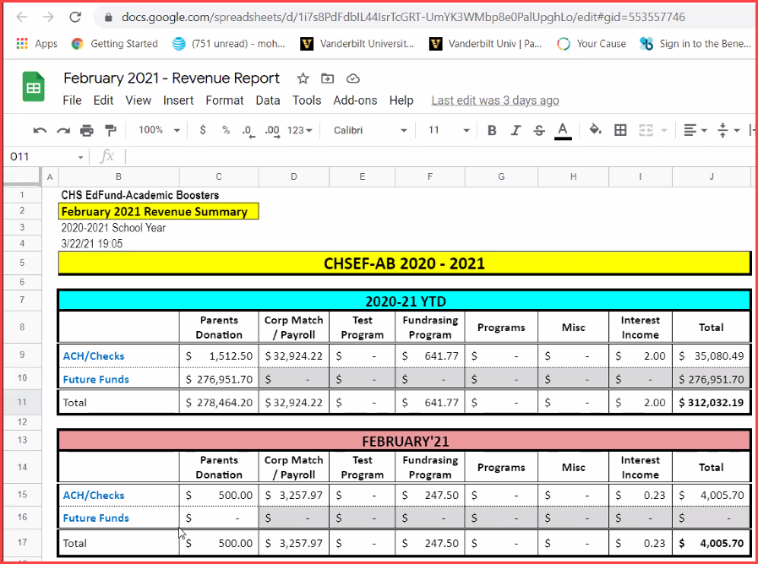

- Treasurer’s Report as of Jan 31, 2021 – Susan McGrath
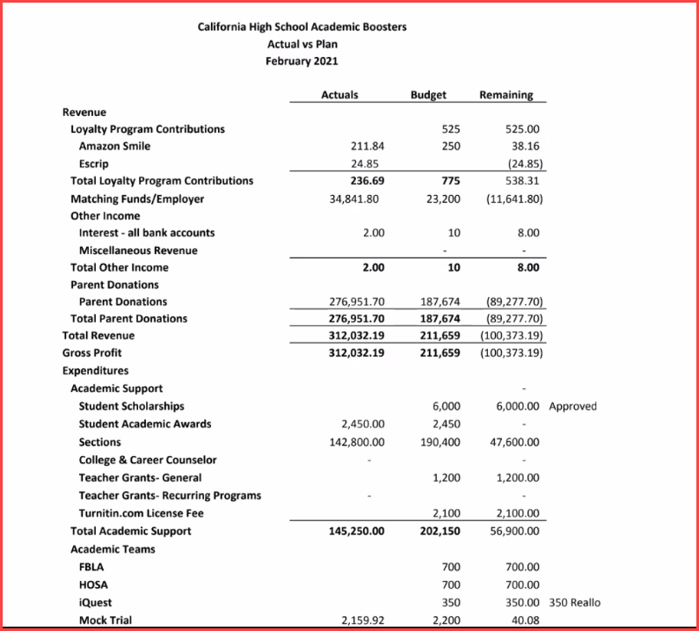

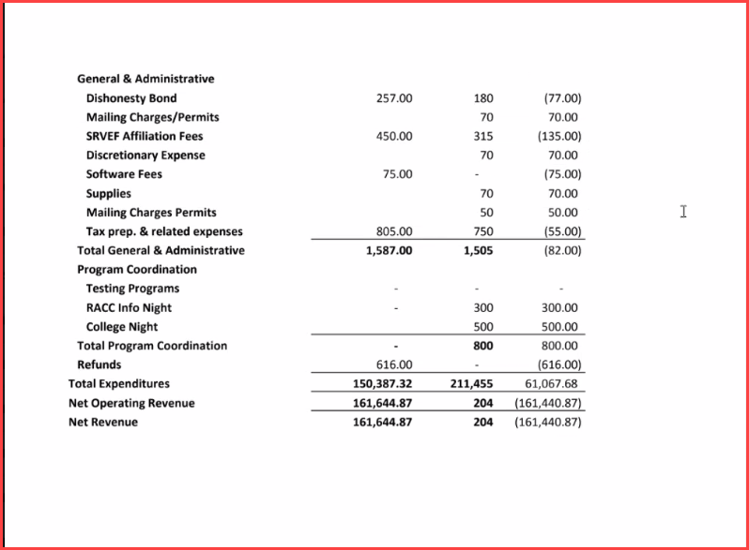

- $6000 scholarship approved
- Reallocated some money
- Preliminary budget

Approved the treasure report for Feb 2021

- Principal’s Report – Megan Keefer / Tucker Farrar
  - Principal Report
    - Open hybrid Wed - ~500 in total, ~250 students per day. Lunch is more fun
  - Library
    - Estimate to replace sound systems – 15K
    - If we can split three ways, academic takes 5K portion
    - Verbal approval for no more than $5000
  - Theater
    - Drama Boosters / Music Boosters /Academic Booster
    - Not decide on the % yet
    - Verbal approval for no mor than $2500

Susan: Need an email for the supporting document from Tucker Farrar. Academic Booster will write the check in April meeting.
Financial year is July 1st to June 30th

- Teacher’s Report – Sarah Eddings
  - Teachers are getting the vaccines
  - Hybrid learning
    - 40% freshmen

- President’s Report – Anshu Jain
  - Commitment letter update – Career Counselor
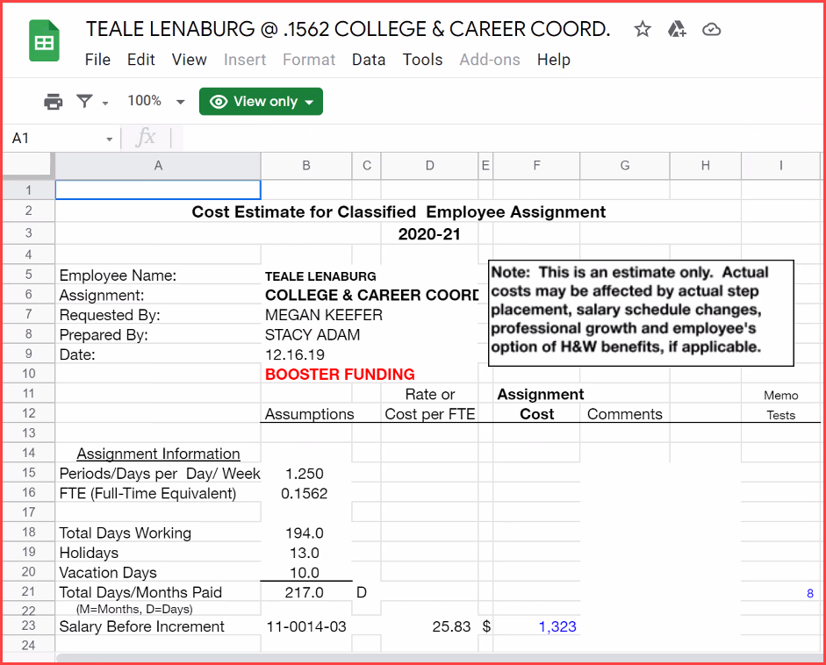

    - Board discussed a refund of .6 of a position due to Cal High for previously paid but unused teacher position funds. Board approved leaving the funds with the District, with the understanding it would be allocated partially to a College and Career Counselor (previously approved by the Board), with the remaining to be applied as Cal High Administration sees need.
  - Elections
    - Send Anshu an email

- Committee Reports:
  - Teacher Grants Report – Anshu Jain
    - English History Teacher request
    - #1277 for $200, check written to Cal High
  - Senior Scholarships Report – Wunmi Kamson / Lei Yang / Joanne Hunt
    - Download the reports and remove the names
    - Forward to Ms. Young
    - Lei will get together with Wumni on this
  - Corporate Matching Report – Sarah Montes / Carol Moore
  - Communications – Monica Belani
    - Get board there in bear fact

- Any other items for open discussion
- Adjournment

NOTE: Future Meetings: 4th Monday of the month
- Apr 26, 2021 (7 to 8pm)
- May 24, 2021 (7 to 8pm)

