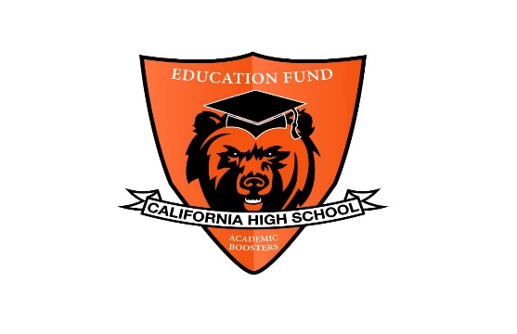
California High School Academic Booster Meeting Minutes
Mon, Feb 22, 2021
6 – 7pm
Online via Zoom

- Welcome - Anshu Jain

- SRVEF Report – SRVEF Director, Gary Alpert

- Approval of minutes as of Jan 31, 2021 – Lei Yang
  - Approved

- Financial Secretary Report as of Jan 31, 2021 – Wunmi Kamson / Susan M
  - Dec 2020 summary
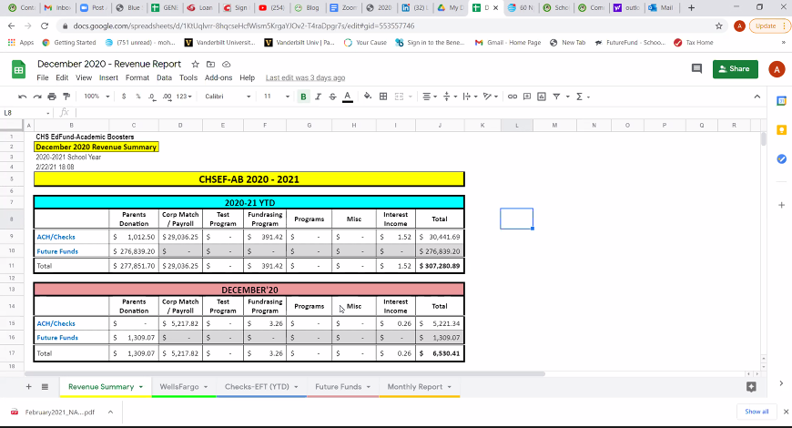

  - Jan 2021 Summary
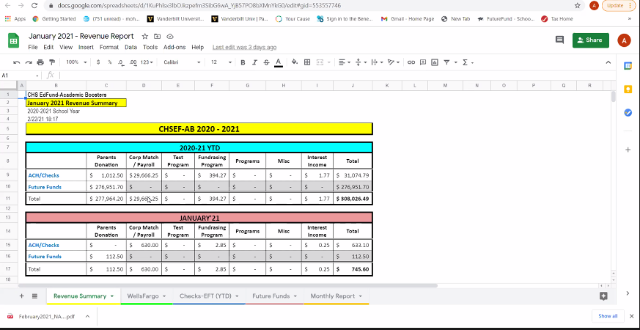

Lei transition role from Susan – pick mail – offline

- Treasurer’s Report as of Jan 31, 2021 – Susan McGrath
- Checks (academic awards $2,450 request by Lisa Olson and any other)
  - approved
- Financials
  - Check # 1274 – approved
  - Susan will forward Lei financials balance for Dec and Jan
- #1274 – Cal High $2450 – Student Academic Awards
- #1275 – Cal High $2159.92 – Grants for Mock Trial – Registration fees and Zoom
- #1276 – Cal High $774.40 – NHS Grant for Graduation Stoles
Approving Dec and Jan financials
- Audit
  - Audit approval for 2019 and 2020

- Principal’s Report – Megan Keefer
- Sections and Commitment Letter
- Other

Update from Megan:
- Grateful for the work done for Cal High
- What is working, not working, supports students
- Welcome students back on campus
- Provide fun activities
- Counseling
- Academic funding couple of teachers
- Students
  - How do you identify students in needs?
- Opportunities to build culture and supports kids
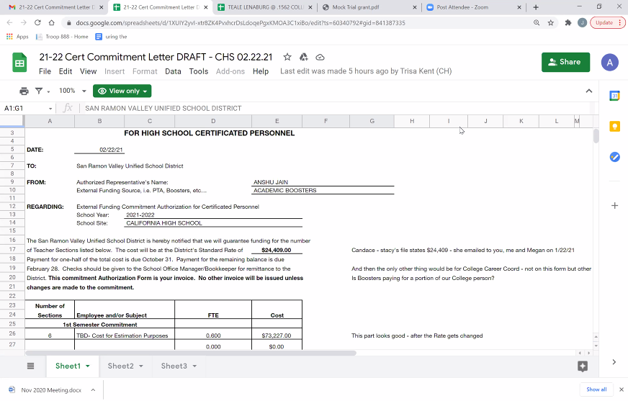

- Commitment letter
  - Need to sign off in March
  - Different than 2020, it is a commitment, not a check
  - Discussion recently. What school think they may need

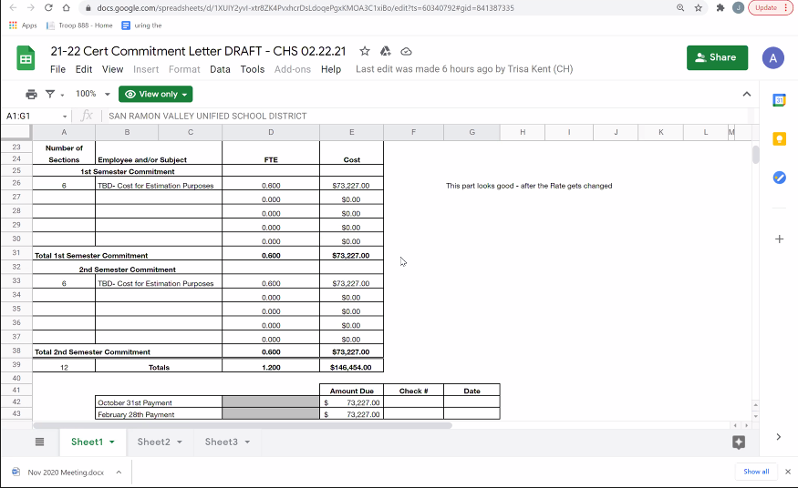

Approved 21-22 Cert Commitment Letter DRAFT

- Teacher’s Report – Sarah Eddings
- 2nd master – improvements, training at the end of 1st semester. More smoothly
- Grace period for hybrid
- Things are under control
- Hard for seniors
- NHS Fund – Susan request to get this approved

- Committee Reports:
- Teacher Grants Report – Anshu Jain
  - Mr. Barr (see attachment to the email)
    - Requesting registration for Mock Trial - $2040
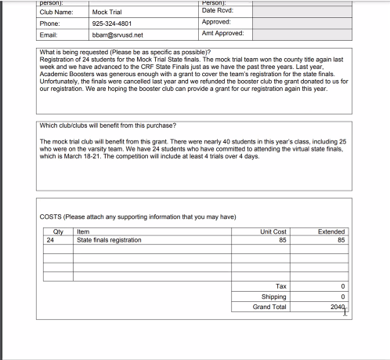

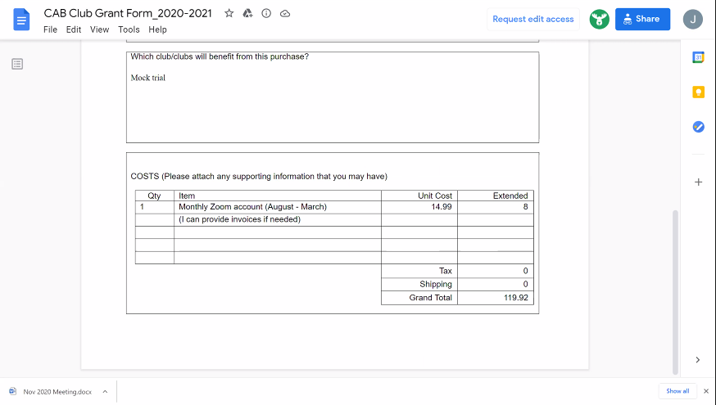

$2040 and $119.92 – combined for Mock trial

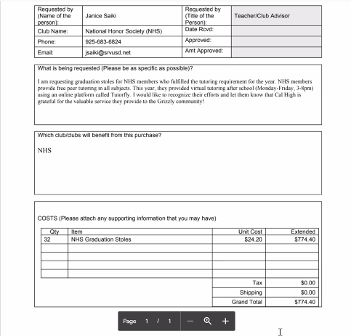
  - Ms. Saiki (see attachment to the email)

- Senior Scholarships Report – Wunmi Kamson / Lei Yang/ Joanne Hunt
  - Motion to approve at least 4 more scholarships so, total 6 scholarships amounting to $6,000

Approved to increase from $2,000 to $6,000 for senior scholarships
- Corporate Matching Report – Sarah Montes / Carol Moore
  - No update
- Communications – Monica Belani

- Budget request for 2021 – 2022 Tucker Farrar
  - Theater and Library sound system update
    - 5,000 for academic
  - College and Career Counselor
    - Similar from last year
    - 15% of the college and career counselor
    - ~ $13,000
    - Not in the commitment letter

- Any other items for discussion
- Adjourn

NOTE: Future Meetings: 4th Monday of the month
- Mar 22, 2021 (7 to 8pm)
- Apr 26, 2021 (7 to 8pm)
- May 24, 2021 (7 to 8pm)

